HITEON SCIENCE EXPO

Thursday, March 12, 2020 6:00pm – 8:00pm

That’s right! It’s time to let those scientific minds fly and design an experiment reflecting your curiosity and interests. You can do an experiment, create an invention, or reverse engineer an existing product – your choice!

Deadline for registration is Friday, February 14th. Please turn in your registration forms on time (to your teacher) – you don’t want to be left out of the fun! Each entry (individual or team) receives a free project display board to be sent home the week of Feb 17-21.

Here are a few guidelines for participating:

- Pick a project idea and sign up, either individually or with Hiteon friends/siblings - up to four students may work together. Only one entry form is needed per project. The parent signing the form must ensure that all parents are aware and in agreement. (Students should only officially participate in 1 project registered for the Expo).

- You may work with your family to do your project, but remember it should be your work and your words explaining it!

- Review safety guidelines below. Bring your completed project board to school anytime between 6:00pm and 6:30pm on the night of the Expo. Project reviewing will begin at 6:30 starting with projects done by kindergarteners and progressing by grade through fifth graders. Once your project is reviewed you can pick up your participation prize! This is not a competition, so relax, have fun, and enjoy!

- Additional tips for parents and students, including online resources for project ideas can be found on the Hiteon PTC Website at: http://hiteonptc.org/our-enrichment-programs/science-fair/

- Please contact karlmeyer@comcast.net with any questions.
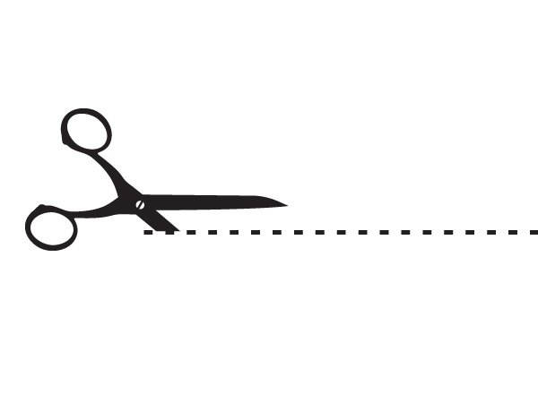
- - - - - - - - - - - - - - - - - - - - - - - - - - - - - - - - - - - - - - - - - - - - - - - - - - - - - - - - - - - - - - - - - - - - - - - - - - - - - - - - - -

Hiteon Science Expo 2020 Entry Form
Please Return to your teacher by Friday February 14th 2020

 | First Name | Last Name | Grade | Teacher
1*
2
3
4
*First person listed will receive the project board to take home

Project Type: Circle one: Experiment Invention Reverse Engineering (not eligible for District Expo)

Parent Signature (one per group) ___________________________ E-mail: _______________________
Note: parent signing for a group must ensure that all the parents are aware and in agreement.

[ ] Check this box if you have a science board you can reuse, and do not need a new one.

[ ] Check this box if you would like to enter the LOTTERY for a chance to participate at the Beaverton School District Expo at Tektronix in Beaverton (Date is still TBD, but will be in early May). Projects will be randomly drawn from grades 1-5. (Must provide email above to be notified)

Hiteon Science Expo Safety Guidelines

Keep in mind – School District rules apply, SAFTEY FIRST!
Although it might be exciting to bring materials used during your experiment to display in front of your board, some items are not ok to bring to school. Please refer to the below list of items not allowed with your display. If in doubt, use drawings or pictures to provide evidence of your experiment.

Not Allowed at display:
- Living organisms-plants or animals or dead parts of animals or plants
- Dirt, soil, bark chips or sand
- Aerosol bottles or other pressurized gases
- Hazardous or flammable chemicals. All other chemicals and liquids, including water, must be in permanently sealed, unbreakable containers.
- Hazardous substances or devices including lasers
- Sharp items or weapons (including toy guns)
- Anything that needs to be plugged in
- Flames or highly flammable items
- Liquids not contained in sealed, unbreakable containers
- Any human or animal food
- Balloons
- Glass
Please contact karlmeyer@comcast.net with any questions.

