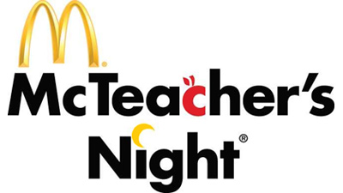

**5-6pm**

**Mrs. Strong**

**Mrs. Schmidt**

**Mrs. Paldino**

**Mrs. Griffith**



**Thursday, November 6th**

**5-8pm**

**Scholls Ferry McDonald**

**12388 SW Scholls Ferry**

**6-7pm**

**Mrs. Humphrey**

**Mrs. Rogers**

**Mrs. Klingner**

**Ms. Warren**

**20% of the food**

**sales and 60% of the**

**cookie sales from McTeacher’s Night**

**will be donated back to the school!**

Please remember to bring **CASH** for cookies sold by Hiteon teachers/staff.    
Debit, Cash, and Credit can be used for food at the registers.

A portion of the donation received from McDonald's, based on the time worked, will be deposited into the discretionary fund for each of the teachers/staff members participating.

**7-8pm**

**Mrs. Hamilton**

**Mrs. Belisle**

**Mrs. Henry**

**Mrs. Hassold**