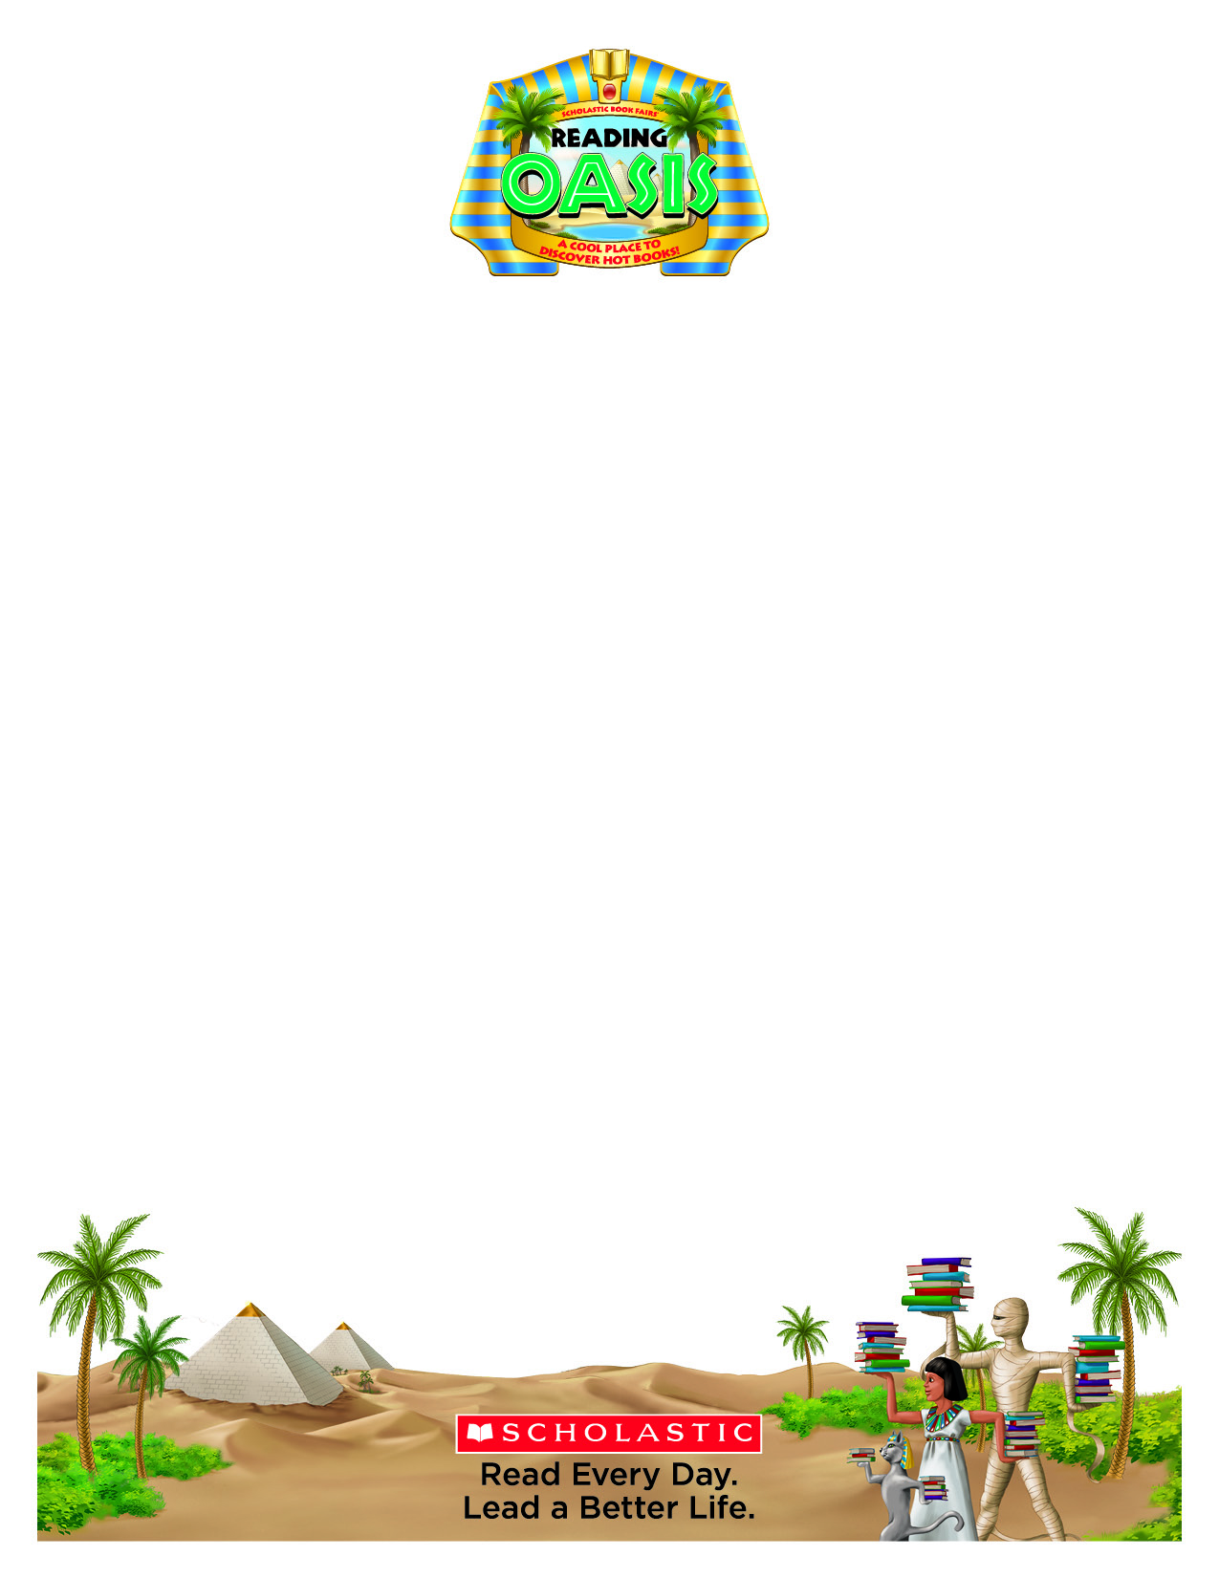**Dear Hiteon Families:**

Reading is the most important skill you can teach a child. Of all the skills children learn, it is the one you can influence the most. We invite you to visit our Scholastic Book Fair and experience a celebration of reading that provides families the opportunity to get involved in a universal mission: *encouraging kids to read every day so they can lead better lives.*

Our Book Fair theme – **Reading Oasis: A Cool Place to Discover Hot Books!** – takes students on a journey back to Ancient Egypt to an oasis overflowing with fun, engaging, and affordable books kids want to read by providing kids’ access to good books and the opportunity to choose books that will motivate them to read even more. And like most acquired skills, the more kids practice reading, the better they’ll get.

Reading is vital to every child’s success, and raising kids as readers means getting involved while they’re young. Now is the time. Since there will never be a substitute for a parent’s direct involvement in his/her child’s education, please make plans to visit our Book Fair.

**Book Fair Dates: Monday October 28th – Friday November 1st 2013 – During School Hours**

**Special Events: Family Fun Night – Wednesday October 30th 2013 – 3:30-6:30 pm**

**Students will visit the book fair during their class’ library time and will able to make purchases during this time. We’d like your help to make sure this is an enjoyable experience for them. When sending money with your child, please make sure to secure it in an envelope or plastic bag with your child’s name on the outside. Some teachers will collect book fair money to ensure it is not lost. Others will leave the responsibility up to the students. The preferred method of payment from the students is cash, if you must send a check, please attach a note giving permission and the amount allowed to spend. THANKS FOR YOUR HELP IN THIS AREA!**

If you’re all booked up during book fair week be sure to visit the book fair online at www.scholastic.com/fair. Our online fair is available for an extended time, 10/28/13 to 11/8/13. Your orders will be sent directly to the school.

We look forward to having you participate in our fair, and remember, all purchases benefit our school.

**Sincerely,**

**JoLanda Starke & Lori Squire**

10950 • 131816

**Hiteon Elementary Book Fair Chairs**